Remove this problem cities requiring attention section from the ‘geography’ tab
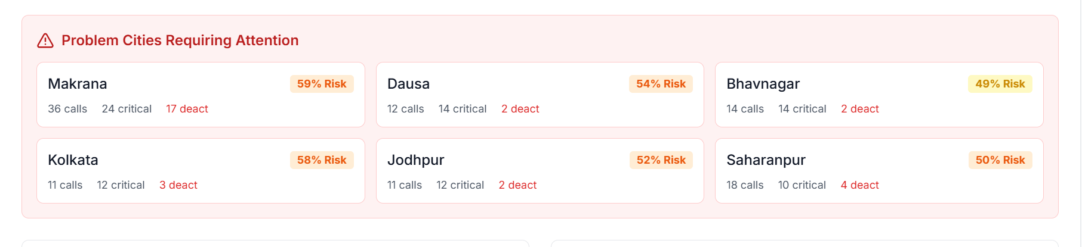

Remove this sentiment journey analysis section from the pattern analysis tab
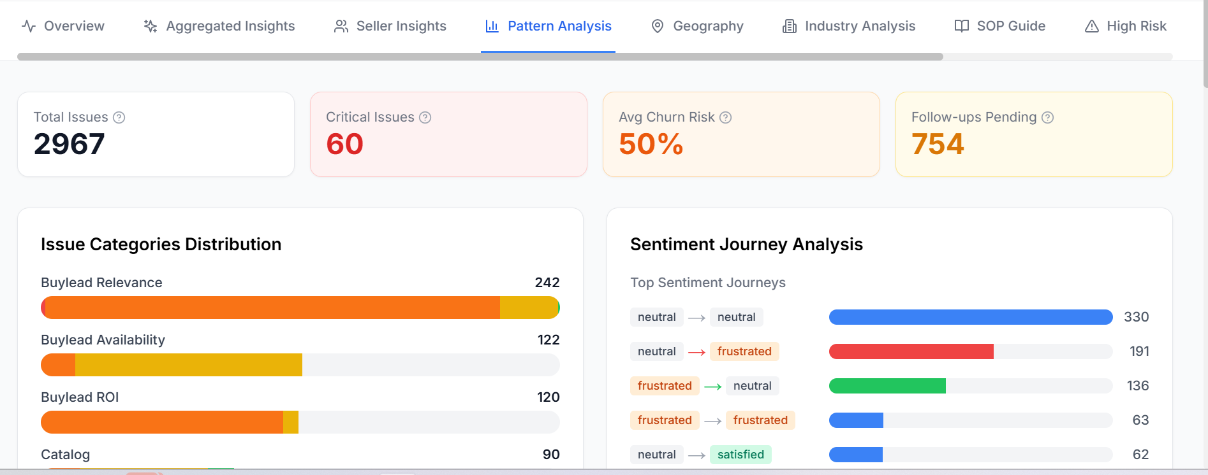

Total number of calls shown here in the doughnut chart are only 100, expand it all the calls analysed and add it in the overview section
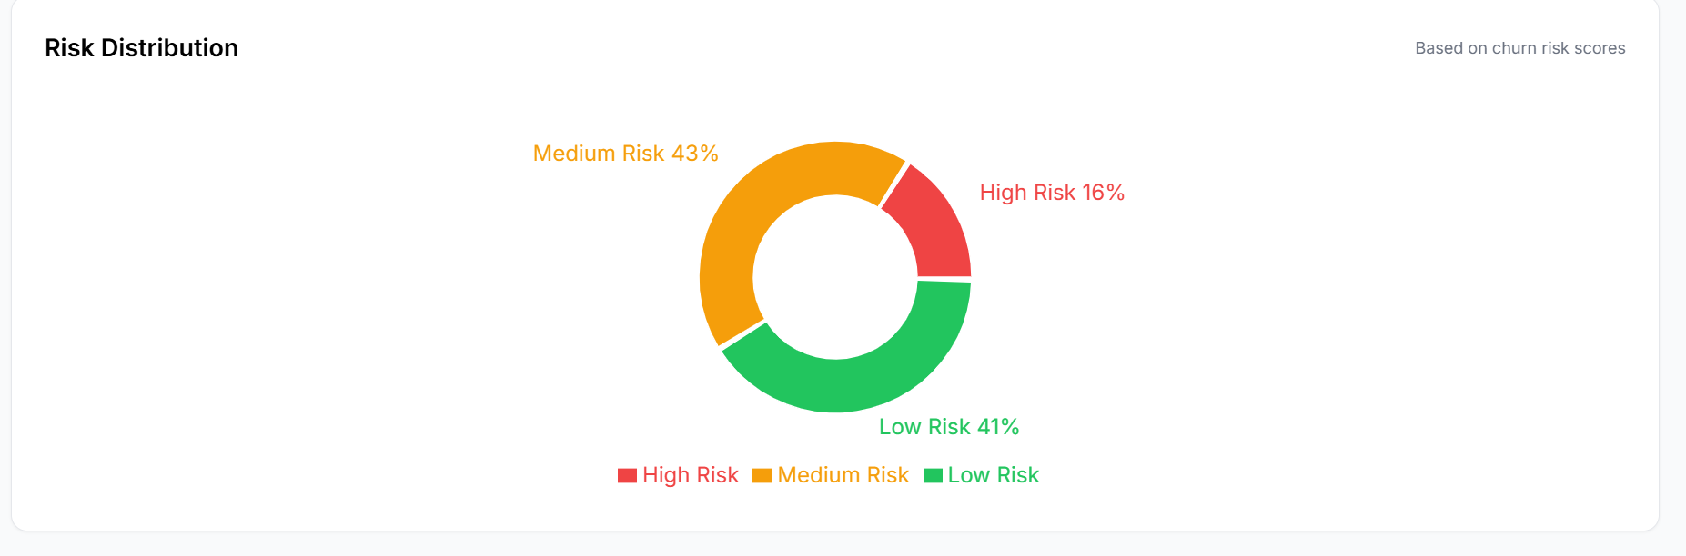

Remove this section ‘high churn risk calls’

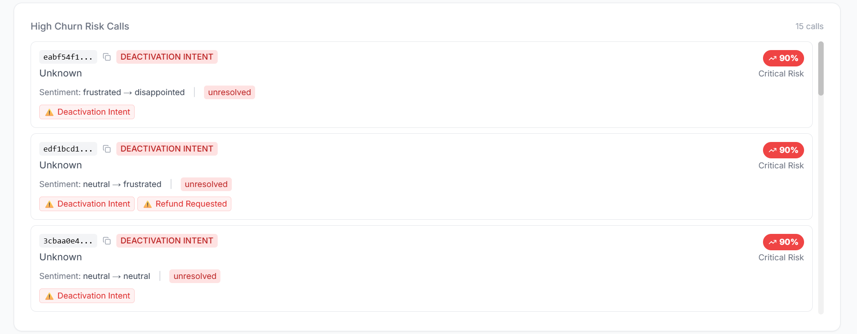

Remove this as well, the sentiment analysis here
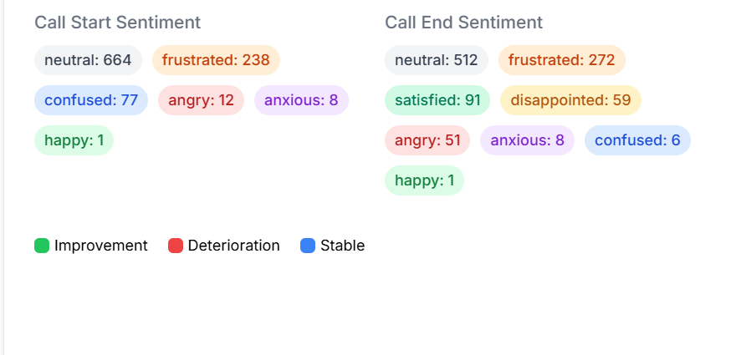
Remove discussion topics in the pattern analysis tab

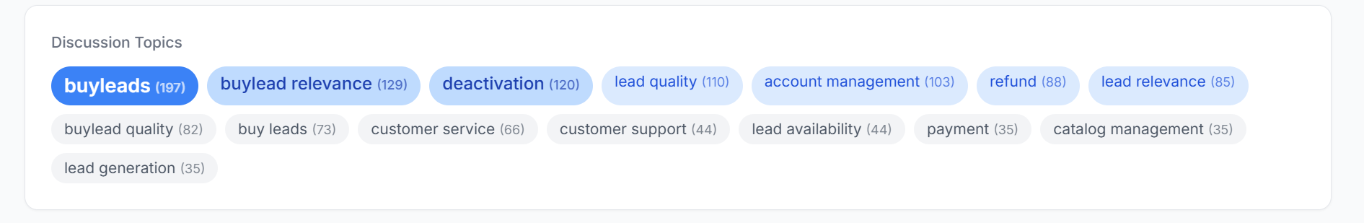

Remove this ‘Critical & High Priority Issues’ in the pattern analysis tab
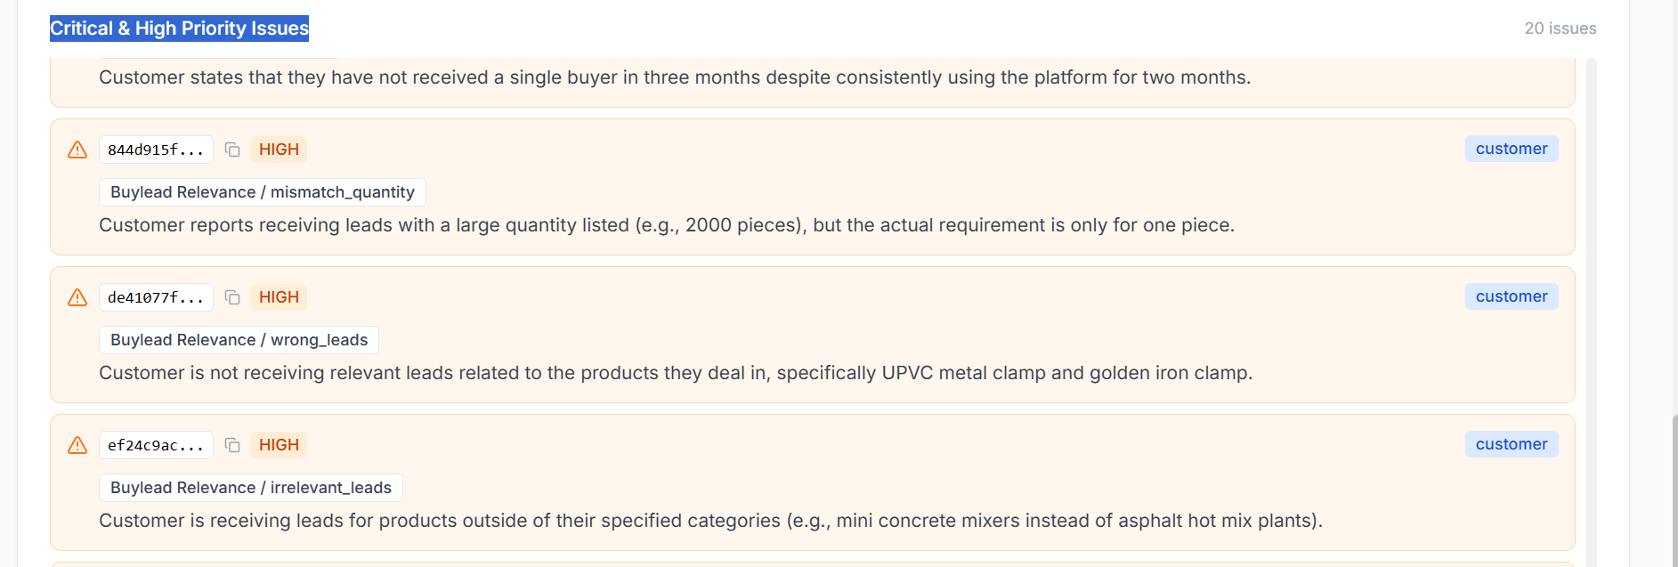

’In the seller insights, there several statements tagged as a single overlying issue, keep it but in the brackets also include their subcategory
For eg, in the below screenshot, the buylead_relevance is repeated so for each issue, after buylead_relevance in the bracket add its subcategory issue

Also remove ‘key quotes’ if there are none to mention
